Maintenance Manager
Release Notes v4.4.0.0

Contents
1 Document Control 3
1.1 Author 3
1.2 Document Summary 3
1.3 Document History 3
1.4 Reference documents 3
1.5 Distribution 3
1.1 Quality Assurance 3
2 Introduction 4
2.1 Pre-Requisites 4
3 Functional Changes 5
3.1 Inspection Loader Error Correction and Summary Form (Enhanced) 5
3.2 Inspections Form – Defect Co-ordinates (Enhanced) 8
3.3 Works Order form – Copy Buttons (Enhanced) 9
3.4 Works Order form – Authorise / Instruct Works Order (Enhanced) 9
3.5 New MAI User Data form. 12
3.6 Works Order and Works Order Line Comments via CIM. 13
3.7 Works Order Line Target Date. 14
3.8 Works Order Line Budget Reallocation, 16
3.9 Automatic Works Orders – SISS Code (Enhanced) 17
3.10 Automatic Works Orders – Ruleset Conflict Checker (New) 18
4 Log No. Summary 20

- Document Control
  - Author
Exor Development

  - Document Summary
This document provides information about functional changes and a list of all logs fixed in this release.

  - Document History

Document History
Revision | Date | By | Description
1.0 | 11-FEB-2011 | Exor Development | First Edition

  - Reference documents
None

  - Distribution
Exor Customers, Partners and Staff

  - Quality Assurance
Document Details
File | Prepared By
Maintenance Manager at v4.4.0.0 | Exor Development
Document Name | Reviewed By
Maintenance Manager at v4.4.0.0 | Mark Lowe
Version | Approved for issue by
1.0 | Colin Stewart
Date of Issue | Support Manager
27-MAY-2011 | Graham Anns

- Introduction
This document defines the changes made to the Maintenance Manager product at release v4.4.0.0 plus a list of all logs fixed in this release.

Unlike the “Maintenance Manager Installation/Upgrade Guide”, this document is specifically targeted at the Maintenance Manager end user. Therefore, if the recipient of this document is an IT person please ensure that it is forwarded on to the relevant end user(s).

This document does not comprehensively describe the functionality of the product, or act as a User Guide.

Please note that any data shown in example screenshots does not represent any Customer’s live data; it is test data set up by Exor.

After reading through this document, should you have any further Maintenance Manager training or Consultancy requirements then please contact your Exor account manager.

  - Pre-Requisites

No pre-requisites at this release

- Functional Changes
This section outlines the functional changes made at v4.4.0.0
  - Inspection Loader Error Correction and Summary Form (Enhanced)
The Error Correction form for the Maintenance Inspection Loader has been enhanced to display more information about each Load and to allow it to act as a Load Summary form as well as Error Correction.

When run from the Process Monitor form (HIG2520) or the Process Execution Log form (HIG2540) via the “More Details...” button this form will be automatically populated with the details of the selected load process. Details will be displayed of any:-
- File validation errors
- Data validation errors
- Successfully loaded inspections

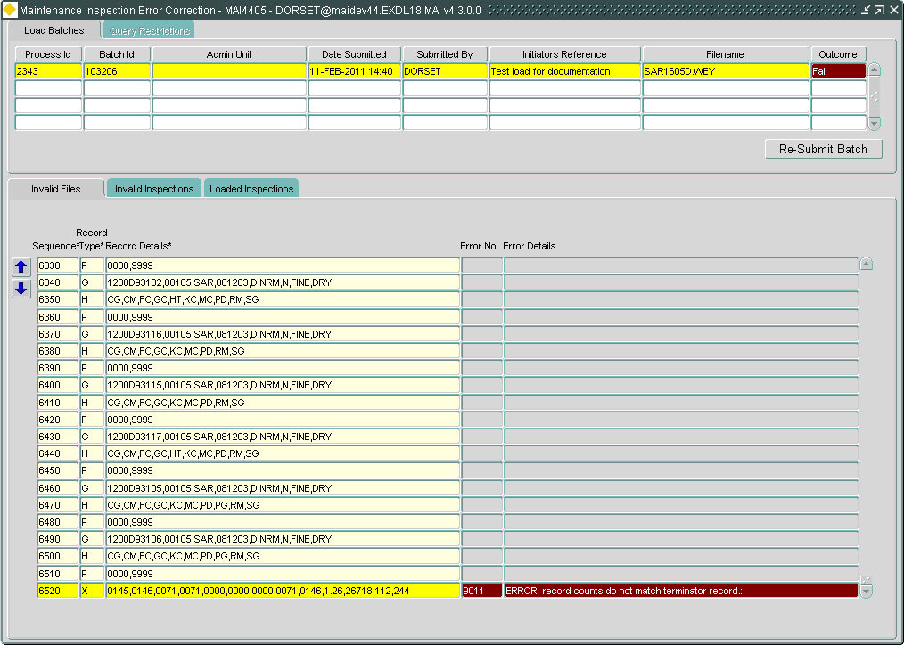

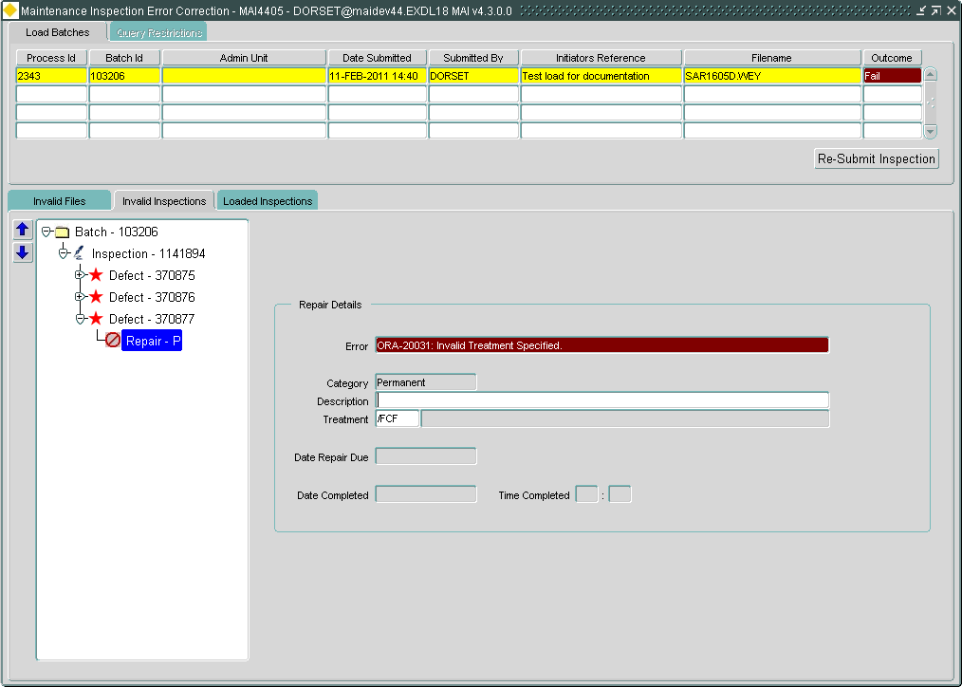

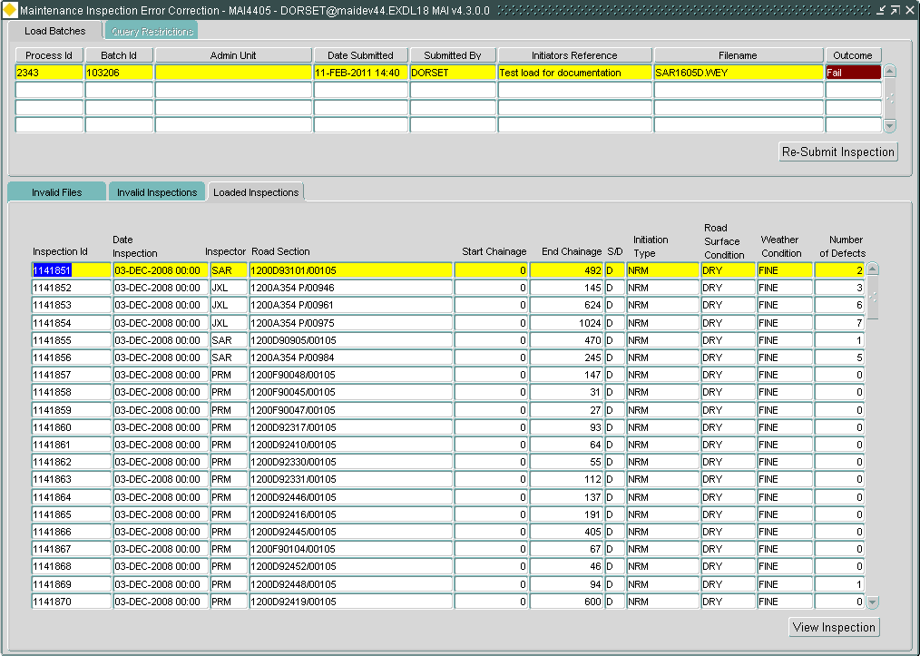

As was previously the case this form can be used to correct any errors identified and resubmit the load.
In order to help find the errors in large files buttons have been added to the error correction tabs to navigate to either the next or the previous error.

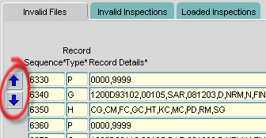

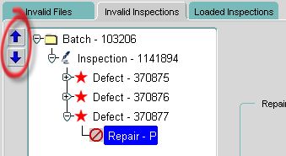

This form can also be run directly from the menu.

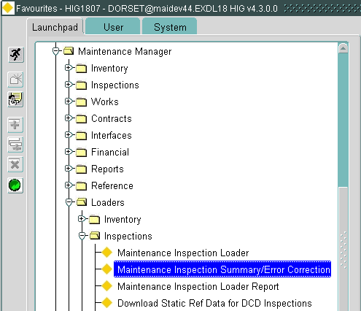

When run from the menu this form can be used to show a summary of Maintenance Inspection Loads.
The User can execute queries in the Load Batches tab in order to view the outcome of any Loads that match the query criteria entered.

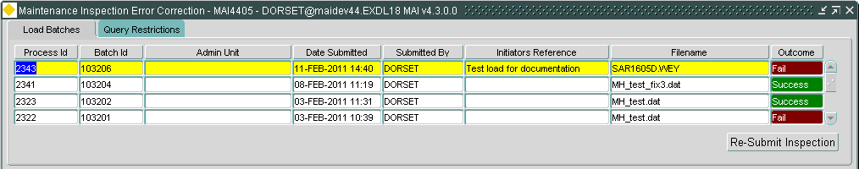

The Query Restrictions tab can be used to further restrict the results of a query.

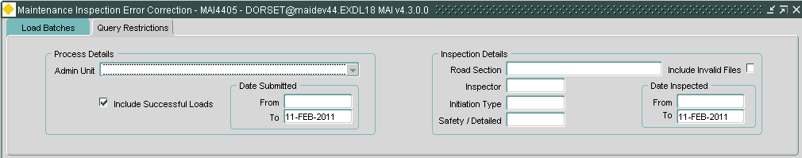

Please refer to the Maintenance Manager User Guide for further information.

  - Inspections Form – Defect Co-ordinates (Enhanced)
The Inspections form (MAI3808) has been enhanced to allow the Defect Co-ordinates to be entered or amended.
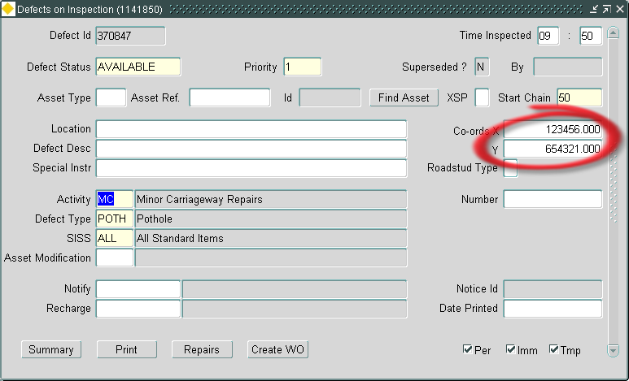

  - Works Order form – Copy Buttons (Enhanced)
When using the Copy button on a Works Order or a Works Order Line the User can now decide whether or not to copy the associated BOQs and if so whether the estimated quantities should be copied or zero estimates used on the new Works Order / Works Order Line.

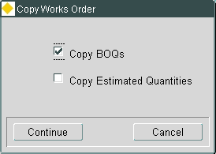
If the Continue button is pressed a new copy Works Order or Works Order Line is created, otherwise if the Cancel button is pressed the User is returned to the Works Order details and no changes are made.

  - Works Order form – Authorise / Instruct Works Order (Enhanced)
Changes have been made to the Works Order Authorisation / Instruction process.

New “To be Authorised By” field.

A new field has been added to the Works Order form (mai3800) to allow the User to nominate another User to Authorise the Works Order.
This functionality is very similar to “Forwarding” a Works Order to a nominated User works in the Works Order Work Tray; in fact setting this field has the effect of ensuring that the Works Order would appear in the Nominated User’s Instruct Works Order Work Tray in the same way that forwarding a Works Order would.
In a similar way if a Works Order is “Forwarded” using the Work Tray the recipients initials will be displayed in “To be Authorised By” in the Works Order form (mai3800).

The “To be Authorised By” field will only accept the initials of a User that would be able to view and instruct the Works Order (see the “User can Authorise” flag in the MAI User Data form below), the nominated User’s authorisation limits are not part of this validation as they may change between the User being nominated and the User actually attempting to Authorise the Works Order.
This field is only enterable up to the point that the Works Order is Authorised.
The population of this field does not restrict Authorisation of the Works Order to the nominated User, i.e. any User with the appropriate settings will be able to Authorise the Works Order.

Amended Authorisation Process.

- A button has been added to the form to be used by the User to Authorise the Works Order. This replaces the need for the User to type their own initials into the “Authorised By” field or use an LOV that only shows their own details.

When the User presses the Authorise button they will be prompted to enter the Date Authorised (defaulted to the System Date).

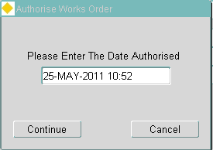

If the Continue button is pressed the Works Order is authorised using the date given, otherwise if the Cancel button is pressed the User is returned to the Works Order details and no changes are made.

Please refer to the Maintenance Manager User Guide for further information.

- The “Authorised By” field can no longer be updated manually.
- As has always been the case the Instruct button will first attempt to authorise the Works Order if it hasn’t already been authorised.

Daily Authorisation Limit.

A “Date Authorised” field has been added to the Works Order which is populated with the system date/time when the Works Order is Authorised via
- The Works Order form (mai3800)
- The Work Orders Authorisation form (mai3848)
- The Works Order Work Tray

When the User attempts to Authorise a Works Order this date field is used to determine the total value of Works Orders already Authorised by the User on the same day.
If the value of the current Works Order would lead to the User’s Daily Authorisation Limit (see the “Max value per Day” field in the MAI User Data form below) being exceeded an error will be raised and the current Works Order will not be Authorised.

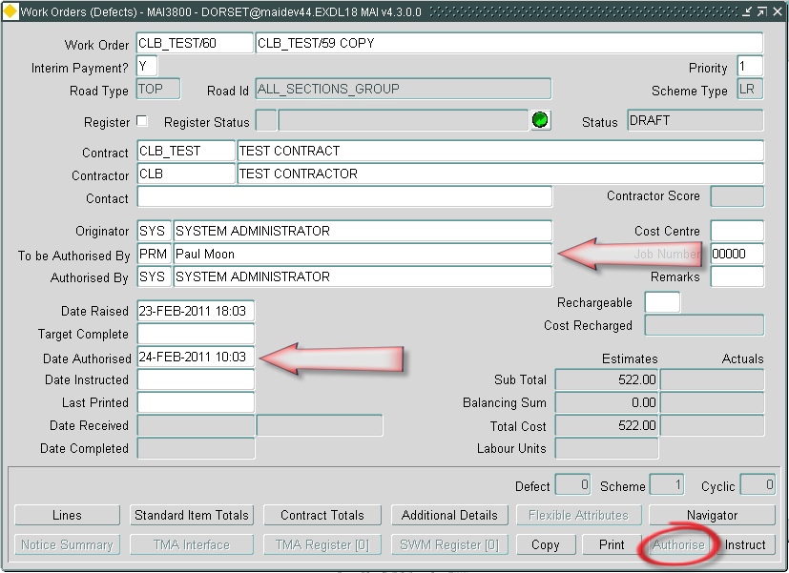

Amended Instruction Process.
The Date Instructed field is no longer directly enterable.
Providing the User is allowed to instruct Works Orders (see the “User can Authorise” flag in the MAI User Data form below) the Instruct button should be used to instruct a Works Order.
When the User presses the Instruct button they will be prompted to enter the Date Instructed (defaulted to the System Date).

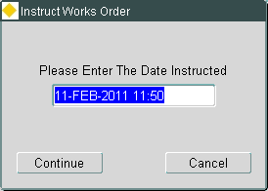

If the Continue button is pressed the Works Order is instructed using the date given, otherwise if the Cancel button is pressed the User is returned to the Works Order details and no changes are made.

  - New MAI User Data form.
Two new fields have been added to the Works Order related information that can be recorded against a User.
Previously this information has been stored in the Core HIG_USERS table, however it has now been moved to a new MAI_USERS table.
A new form has been created to maintain the data stored in the new table.

A full description of the fields in this form will be given in the Maintenance manager Admin v4.4 guide but basically the fields that have been moved from hig_users function in the same way they did before, the two new fields are explained above.

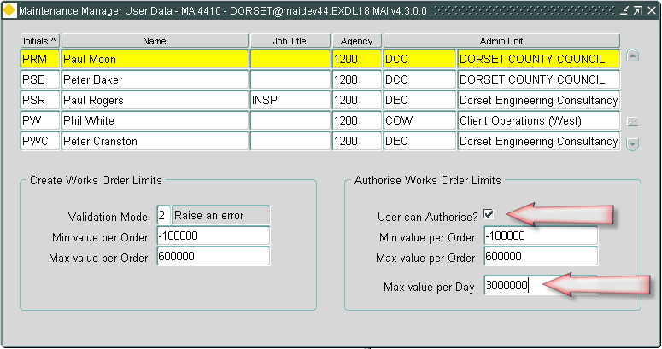

  - Works Order and Works Order Line Comments via CIM.
The Remarks fields on Works Orders and Works Order Lines have been expanded to 1000 characters and added to the CIM file as new record types.

The Works Order Remarks field (Comments) are included in the WO file as an 07 record.

The Works Order Line Remarks field (Comments) are included in the WO file as an 11 record.

Each of these record types will be in the format:-

Character (2) Record Type
Character (1000) Remark

For Example:-

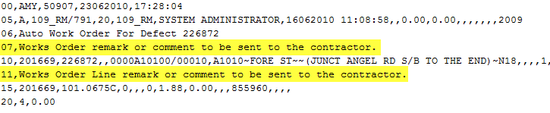

In order to include these new record types in the WO file a new Product Option (CIMINCRMKS) will need to be set to ‘Y’.

  - Works Order Line Target Date.
A new Target Date field has been added to the Works Order Lines displayed in the Works Order forms (MAI3800 and MAI3802).

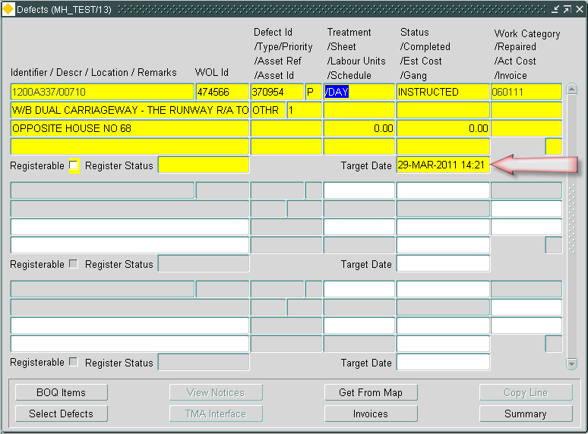

This field will be automatically populated when there is a Repair associated with the Works Order Line, either when the Works Order is Instructed or when the Repair is selected onto an Instructed Works Order.

The date used to populate it will be either:-
- The associated Repair Due Date.
or
- A date calculated by applying the same Interval used for the Repair Due Date to the Works Order Instructed Date. The interval used is derived from the associated:-
  - Defect Activity
  - Defect Priority
  - Repair Category

The application determines which of the above methods to use based on a new tick box displayed and maintained in the contracts form (MAI3880).

If the “Recalculate Repair Due Dates” box is ticked the Target Date will be recalculated otherwise the Repair Due Date will be used.

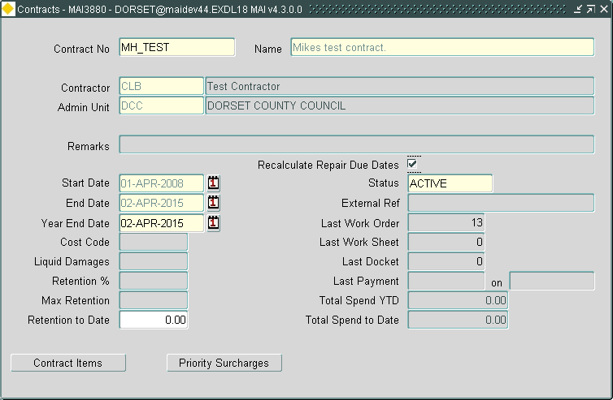

When the Works Order Line is not associated with a Repair the field will allow the User to manually enter a Target Date.
The Works Order Target Complete field in MAI3800 will be maintained so that it represents the latest Target Date of all the associated Works Order Lines, this will override any Works Order Target Complete calculated as a result of the Works Order Priority.

NB. In addition to the above changes a time element has been added to the Works Order Instructed Date in order to cater for intervals measured in hours rather than full days.

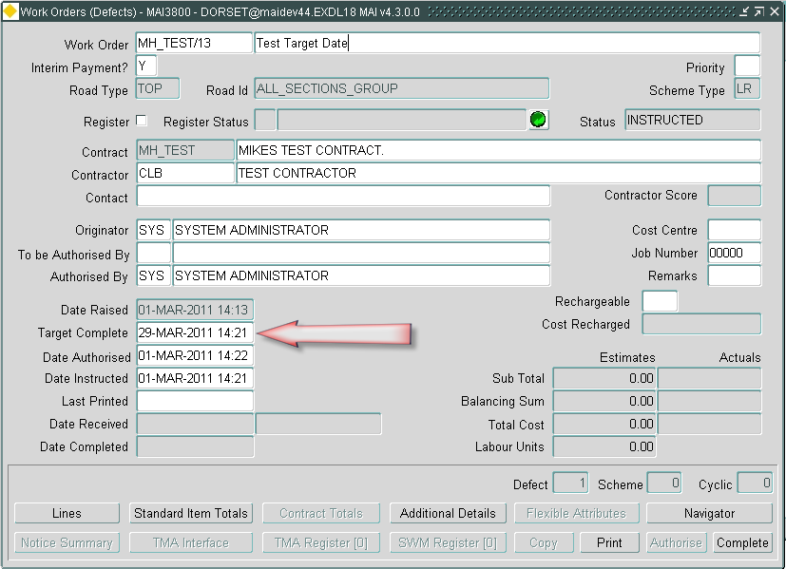
  - Works Order Line Budget Reallocation,
A new “Budget Reallocation” form has been created.

This new form allows the User to query any completed Works Order and amend the Budget on each individual Works Order Line to another appropriate budget.

The selected Budget must satisfy the following criteria:-
- There must be sufficient balance available to accommodate the Actual Cost of the Works Order Line.
- The Financial Year must be either the same as that of the original Budget or the following Financial Year.
- Must satisfy the normal validation that would be applied by the Works Orders form (MAI3800)

When a Budget change is performed the Actual Cost of the Works Order Line will be removed from the original Budget and added to the new Budget.

It is proposed that a new role is created and used to allow specific Users access to this new module via the existing module role security i.e. it is not be shipped with any module role metadata.

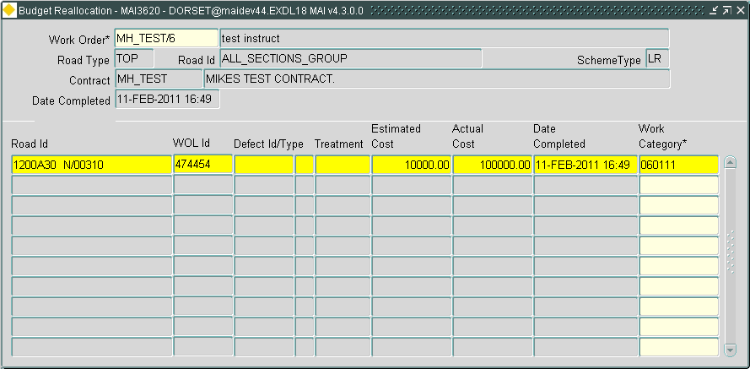

  - Automatic Works Orders – SISS Code (Enhanced)
The Automatic Works Order functionality has been enhanced to allow the specification of SISS Code in the Criteria tab of the Automatic Works Order Rules form (MAI3818).

Please refer to the Maintenance Manager User Guide for further information.

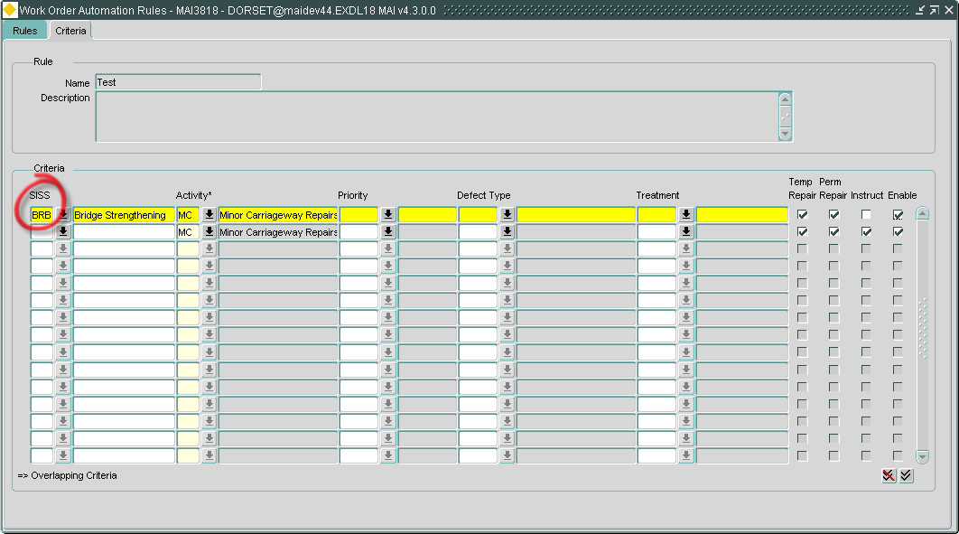

  - Automatic Works Orders – Ruleset Conflict Checker (New)
The system will now check for any criteria overlaps ie. Where the same criteria has been entered against another rule with matching Admin Unit /Road Group details defined for the ruleset, and where the ruleset and criteria are both enabled.

On attempting to enable a ruleset, where conflicting criteria exists, a pop-up will be displayed to the user:

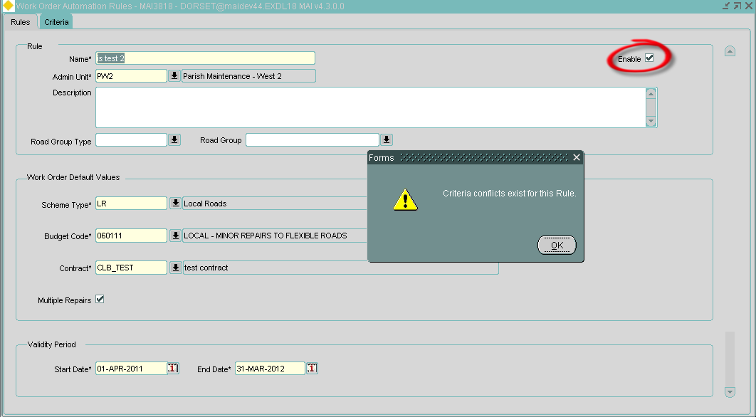

An indicator ‘=>’ will be displayed against the conflicting criteria and the enabled checkbox will be un-ticked:

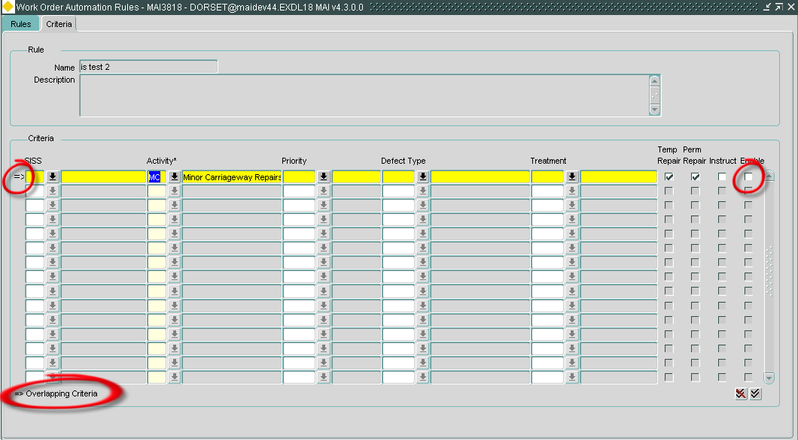

When attempting to enable criteria that conflicts, a pop-up will be displayed detailing the ruleset where the criteria has already been defined and the conflict indicator => will appear against the conflicting details.

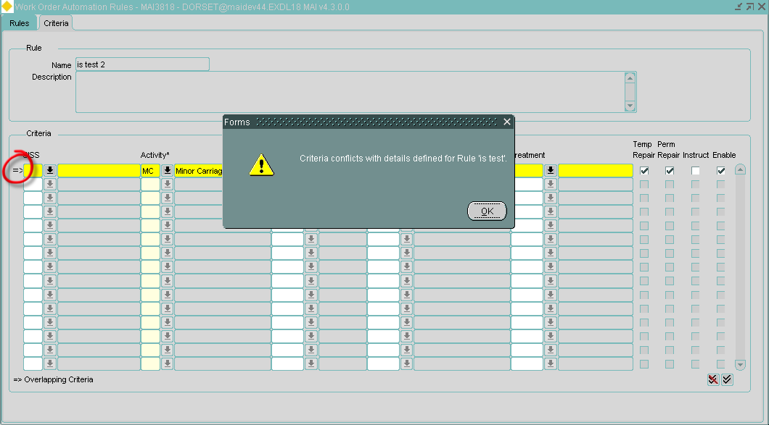

- Log No. Summary
This chapter summarises all Software Changes (enhancements and new functionality) and Bug Fixes that have been made in this release.

These changes are derived from the following sources,

- Issues raised by Customers via Exor Support
- Issues raised internally by Exor

Internal  Task ID | Issue | Support Log(s)  And Ticket Number(s)
0107258 | The Defect Location Description and Works Order Line Location Description fields have been expanded to 1000 characters.  NB. When passed into the MAI to TMA interface these fields will be truncated to 120 characters in accordance with the EToN specification. | 716498  727959
0107344 | The Inspections form (MAI3808) has been changed to allow the User to edit the Defect co-ordinates fields. | 717174  728729
0107386 | Corrected a problem in the Works Order form (MAI3800) that was allowing Users to exceed their maximum Works Order value when adding Percentage Items to existing BOQs. | 718152
0108072 | Works Order form (MAI3800).  When using the Copy button on a Works Order or a Works Order Line the User can now decide whether or not to copy the associated BOQs and if so whether the estimated quantities should be copied or zero estimates used on the new Works Order / Works Order Line. | 719711
0108907 | The Contracts form (MAI3880) has been changed so that when adding a new Contract Item the Standard Item used must have:-  1, A Start Date that is either NULL or predates the Contract End Date.  2, An End Date that is either NULL or postdates the Contract Start Date.
0109137 | A number of Works Order related reports have been amended to correctly display Actual Labour Units:-  MAI3906 - Print BOQ Work Order (Defects)  MAI3907 - Print BOQ Work Order (Cyclic)  MAI3924 - List of Instructed Work by Status  MAI3970 - Print Gang Work Orders | 722555
0109307 | View Cyclic Maintenance Work (MAI3804), the BOQ Description has been expanded to 254 Characters to avoid truncation errors. | 725361
0109606 | The Asset Type LOV in the Inspections form (MAI3808) has been amended to allow it to work for Asset Types that are located on a conflated network. | 726232
0109946 | Works Orders forms (MAI3800 and MAI3802).  Changing the Item code on a BOQ can cause problems, for example:-  When entering Actual Costs, and the Item Code is changed, the Estimated Costs may fall outside of the Quantity Banding implemented by the new Item Code.  When changing the Item Code of a BOQ that has a Percentage Item attached it is possible that the new Item Code does not allow Percentage Items.  A change has been made to prevent the update of a BOQs Item Code if the Works Order has been Instructed or the BOQ has a Percentage Item attached.  If however a Defect/Repair is selected onto an Instructed Works Order and the Repair has an associated BOQ with an Item Code that is not valid for the Contract on the Works Order the User will be able to change the Item Code to one that is valid for the Contract. | 726940
0110020 | The original error correction screen (MAI4405) introduced with the new MAI Inspection Loader in 4300 has been rewritten to make it easier to use for error correction and to allow it to be used as a Loader Summary screen with a filter block so that the user can review the files that have been loaded and more easily see what errors occurred and/or what inspections were created as a result of the load.  The form can be called from the process log for an individual load or from the menu.
0110036 | The Attach Defects button has been re-introduce in the Inspections by Group form (MAI3899) having been removed in a previous release. | 727417
0110178 | The Inspection Initiation Type can now be up to 10 characters in length (previously 3 characters). | 727985
0110227 | Changes have been made to the Inspections form (MAI3808) to prevent the user from manually setting certain Status codes.  Statuses SELECTED and INSTRUCTED (and any additional status codes based on the same feature flags) have been excluded from the list of statuses that can be manually set by the user as these Status Codes are exclusively intended to indicate that a Defect repair has been included on a Works Order, the system will automatically set these Statuses when the repairs are selected onto a Works Order.  The status COMPLETED (and any additional status codes based on the same feature flags) has also been excluded from the list of statuses that can be manually set by the user. Users should be entering the repair completion date to complete Defects. | 728196
0110419 | The Automatic Works Order functionality has been enhanced to allow the specification of SISS Code in the Criteria tab of the Automatic Works Order Rules form (MAI3818).
0110430 | The Print Works Order (Priced) report (MAI3840) has been modified in line with the changes made to Defect Attributes in the 4300 release.
0110474 | Changes have been made to the CIM Automation process to allow the Input FTP folder and the Archive FTP Folder to be on different FTP servers. | 728632
0110575 | Defect Selection in the Works Order form (MAI3800) has previously had a limit of around 5000 defects/repairs that match the specified criteria before an error is raised.  Changes have been made to remove this limitation. | 729347
0110584 | Changes have been made to the Works Order form (MAI3800) Instruction process.  At no point is the date instructed field directly enterable, the Instruct button should be used to instruct a Works Order.  When the user presses the instruct button a popup is displayed allowing them to alter the defaulted sysdate, once continue is pressed the WO is instructed using the date given. | 729394  8001014509
0110615 | The Date LOV has been corrected for the Date/Time Created field in the Defect From Locator form (MAI3807). | 729836  729606
0110619 | Changes have been made to the Works Order form (MAI3800) Instruction process.  At no point is the date instructed field directly enterable, the Instruct button should be used to instruct a Works Order.  When the user presses the instruct button a popup is displayed allowing them to alter the defaulted sysdate, once continue is pressed the WO is instructed using the date given. | 729533
0110635 | Corrected the checking of Notifiable and Rechargable organisations in the Maintenance Inspection Loader so that the organisation type is considered when validating the organisation code from the load file. | 729645
0110658 | A number of error messages used by the Maintenance Inspection Loader have been altered to provide a better description of the problem.
0110686 | The Works Order form (MAI3800) has been changed so that the user can highlight and copy the Works Order Number.  The existing rules regarding the editing of the Works Order Number still apply.
0110691 | Corrected an issue in which The Maintenance Inspection Loader Error Correction form (MAI4405) raised repeated errors (in an infinite loop) when the Batch is highlighted in the tree and the User pressed the "Re-Submit Inspection" button.  The form now asks the User to select an Inspection to be resubmitted and returns focus to the tree. | 8001012703
0110698 | Corrected and issue raised against the new Maintenance Inspection Loader when loading inspections against Sections with a decimal length.  The loader can now deal with the existence of more than one Defect Status Code with feature flag 8 set to 'Y' (SUPERSEDED). Where this situation exists the status code with the highest sequence number will be used by the loader when a Defect is superseded.  Please ensure that the appropriate status code has the highest sequence number. | 729524  729191  729695
0110716 | Improved error handling on the Non-Primary AD attribute blocks on NM0105 (Elements), NM0110 (Groups of Sections) and NM0115 (Groups of Groups). | 8001019779
0110785 | Increased Road Description length for Work Order Templates to resolve error when road description was over 80 chars | 8001034321
0110789 | Corrected an issue in the Maintenance Inspection Loader that was leading to:-  1, Defects being incorrectly marked as completed when one or more of their associated Repairs are not complete.  2, Defects being incorrectly marked as not completed when all of their associated Repairs are complete. | 8001026636  8001030125
0110793 | Corrected the calculation of Repair Due Dates in the Maintenance Inspection Loader to use the Inspection Date rather than the Load Date. | 8001036918
0110803 | Fixed the following problem in the Inspection Form (MAI3808):-  When entering a completion date for a repair in the inspections form, if the completion date is the same as the inspected date get an error saying you're trying to enter a repair date before the inspected date. | 8001036919
0110817 | Inspection Loader - Corrected an issue that causes the incorrect calculation of BOQ Quantity when a Treatment Model is being used in conjunction with a Multiplier. | 8001031516
0110819 | Inspection loader has been modified to identify WO creation and WO instruction success/failure separately. Messaging has been changed to reflect this. So if a WO is successfully created but instruction fails, the process log will now contain a message similar to the following example:  Created Work Order CLB_TEST/71  Failed to instruct Work Order CLB_TEST/71  Warning: ORA-20048: All Work Order Lines Must Be Priced.  Also, the failure alerts produced will indicate that there was a failure to instruct the work order, rather than just specifying that the work order process had failed
0110822 | When loading an Inspection file with Works Order Automation enabled, if AUTH_OWN user option is set to 'Y', message 'Warning: ORA-20075: Users are not allowed to authorise works orders they have raised.' appeared in the Process Log and the Work Order was not authorised.  The Inspection Loader module has been modified to recognise AUTH_OWN user option
0110827 | Inspection Loader - The validation of the record sequence within the file has been changed to allow an I record to follow K and L records. | 8001041573
0110833 | Inspection Loader - The time element has been removed from the processing that checks the Inspection Date from the file against previously loaded Inspections.  This has been done so that the loader does not raise the error message "Error : Inspection Date less than previously loaded inspection. : Correct the inspection date." when Inspections with the same Activites, carried out on the same Section on the same day are loaded out of sequence. | 8001018983  8001029848  8001031292  8001032054  8001036917

